Free and confidential services for survivors of intimate partner violence and survivors of sexual assault.
Serving Clay, Geary, Marshall, Pottawatomie, and Riley Counties and Fort Riley.
YOU ARE NOT ALONE
24-Hour Hotlines
24-Hour Crisis Intervention
Safe Shelter, Food and Subsistence
Safety Planning
Supportive Counseling
Case Management
Advocacy
Children’s Services
Support Groups for Women and Children
Assistance with Protection Orders
Referrals
Community Education and Training
Resources

Services
Free and confidential services for victims and their children
24-Hour Hotlines
Have you experienced or witnessed intimate partner domestic violence or/and sexual assault, or are you concerned about someone who has? We are here to support and listen. Our hotline advocates will provide you with information about resources, referrals, safety planning, and more details about our services.
Local Hotline - 1-800-727-2785
Kansas Statewide Hotline - 1-888-363-2287
Language line available
24-Hour Crisis Intervention
You are not alone.
We are here for you 24-hours a day, 7 days a week. If needed we can meet with you no matter what time of the day at a safe location.
Safe Shelter, Food and Subsistence
The Crisis Center’s shelter offers a safe place for domestic violence and sexual assault victims and their children to heal. The location of this shelter is confidential for the safety of our clients.
The shelter provides a safe and healing atmosphere. All services are free and confidential. Our shelter offers several common areas including the living/dining area, kitchen, playroom, and outside space. While in shelter the Center will provide food, clothing, and toiletries at no cost.
Each resident is assigned to an advocate when they enter shelter. Advocates provide help with attaining goals, referrals, and counseling. Residents and their children have the opportunity to attend support groups.
Our shelter is open 24-hours a day, 365 days a year. Our shelter staff is there to help you begin to heal from abuse and to create a life that is free from violence.
Safety Planning
If you are in immediate danger call 911!
Your advocate will work with you on a comprehensive safety plan for you, your children, and your pets because safety planning should be unique to your individual experience.
Supportive Counseling
Our advocates are available to give support, listen and process in a non-judgmental safe environment
Case Management
Our advocates will work with you directly on a plan to ensure you receive a full range of services as needed. We can provide referrals, personal advocacy, accompaniment support, develop safety plans and assist with protection order needs.
Advocacy
All clients, if you stay in our shelter or receive services as a non-residential client, you will be assigned to a specific advocate. The advocate will assist and guide you through your journey by providing you with emotional support, victims’ rights information, help in finding needed resources, and assistance in filling crime victim-related forms
Children’s Services
Domestic violence is a direct physical threat to children, as well as a mental and emotional one. It can impact their ability to learn, harm their emotional maturity, damage relationships, and influence actions in the future. Our Parent-Child Advocate focuses on the needs of children. The Parent-Child Advocate works with clients to address and find resources for their children.
Support Groups for Women and Children
We offer support groups in a safe and confidential space to connect with other survivors and help victims cope with domestic violence while building healthy
relationships and friendships. Support groups are facilitated by students in the Couple and Family Therapy program of Kansas State University.
Assistance with Protection Orders
An advocate will explain the protection order process and help you decide if this step will be the right way for your situation. The advocate will guide you through the paperwork and accompany you during the court hearing.
Referrals
After speaking with our advocate referrals to other local agencies may be offered. Referrals are specific to each client’s needs.
Community Education and Training
The Crisis Center provides educational programs to churches, schools, and civic groups, and specialized training to professional associations and employee groups. For information, call (785) 539-7935.

Resources
Other Organizations
- KCSDV
- The National Domestic Violence Hotline
- RAINN
- Kansas City Anti-Violence Project
- DEAF LEAD
- Suicide Prevention Lifeline
- National Runaway Safeline

Power & Control Wheel
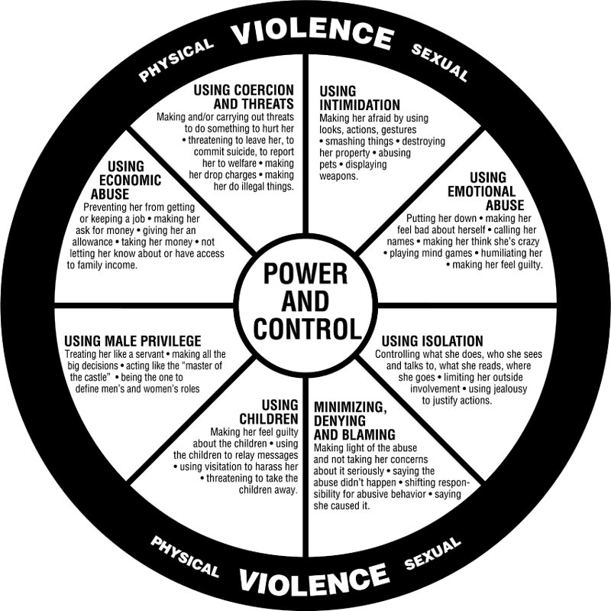
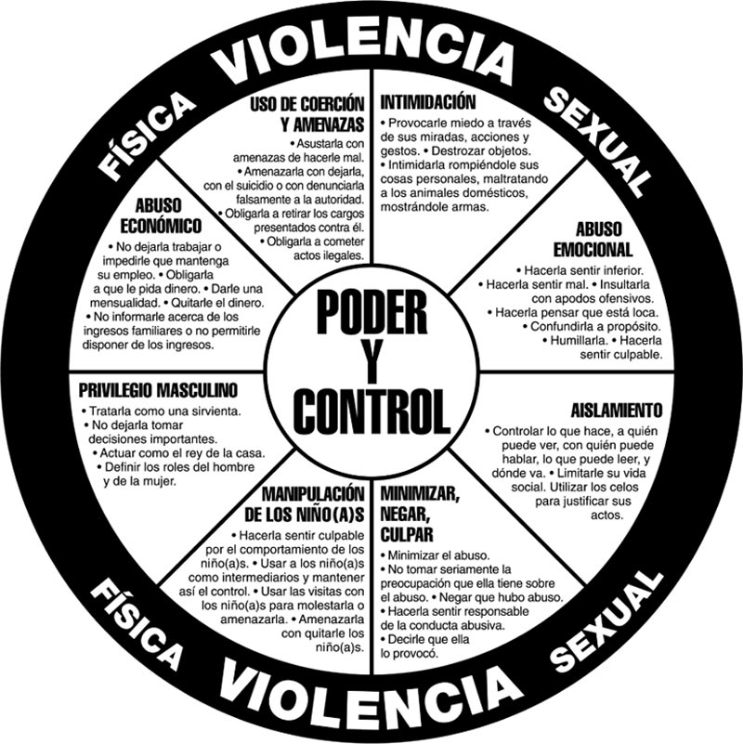

About Us
The Crisis Center, Inc. was founded in 1979 and incorporated in 1981 with a mission to provide free and confidential services to victims of domestic violence and sexual assault. The Crisis Center's mission is centered around helping community members who are in need find safety, security, and a life free from violence. Our trauma-informed services are available 24/7, 365 days a year.
The Crisis Center serves Clay, Geary, Marshall, Pottawatomie and Riley counties, and the Fort Riley military installation. The Crisis Center also administers the statewide Kansas Crisis Hotline.
The Crisis Center is fully accredited for its domestic violence and sexual assault core services through the Kansas Coalition Against Sexual and Domestic Violence.
The Crisis Center is partner agency of the Konza United Way and of the United Way of Junction City-Geary County.

